

Computer Games Development CW208

Technical Design Document

Year III

|  |  |
| --- | --- |
| [Paul Nolan]  [C00213034] |  |
| [03/05/20] | |

Contents

Game Architecture **2**

UML **3**

Class Diagram: RPG Rules 4

**Features** **4**

Feature: Player 5

CRC Cards **5**

Class Name : Player 6

Class Name : NPC 6

**References** **6**

# **Game Architecture**

Game Specific Subsystems and Game Engine Architecture

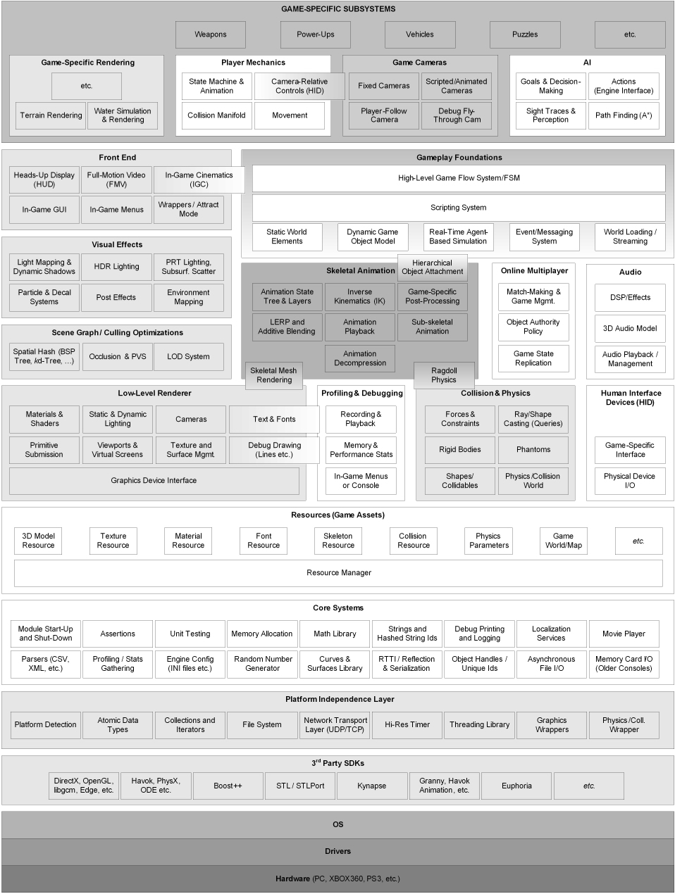

# **UML**

## ***Class Diagram: RPG Rules***

## 

# 

# **Features**

## ***Feature: Player***

Tasks:

1. Create a player class that ….
2. …….

# **CRC Cards**

|  |  |
| --- | --- |
| ***Class Name :*** Car | |
| Subclasses : None | |
| Superclasses : None | |
| Responsibilities | Collaborators |
| Run path generated by algorithm. | Map |
| Represent user in the program. |  |
| Visually show the path being travelled. |  |

# 

|  |  |
| --- | --- |
| ***Class Name :*** Map | |
| Subclasses : None | |
| Superclasses : None | |
| Responsibilities | Collaborators |
| Generate path using the algorithm | Load Map |
| Create a map using loaded data using the Town and Road classes. | Car |
| Visually represent data from the algorithm such as time and the towns used. |  |
| Run the base A* algorithm and output its data such as time taken and path created |  |

# 

|  |  |
| --- | --- |
| Class Name : Load Map | |
| Subclasses : None | |
| Superclasses : None | |
| Responsibilities | Collaborators |
| To load in all data needed to create the map. | Map |

# 

|  |  |
| --- | --- |
| Class Name : Towns | |
| Subclasses : None | |
| Superclasses : None | |
| Responsibilities | Collaborators |
| To represent the nodes used in the algorithms |  |
| Store the ids of connected roads. |  |
| Store the ids of previously visited towns. |  |
| Store the amount of fuel the user had when they passed through the node. |  |

# 

|  |  |
| --- | --- |
| Class Name : Roads | |
| Subclasses : None | |
| Superclasses : None | |
| Responsibilities | Collaborators |
| To represent the arcs used in the algorithms. |  |
| To store the ids of the related roads. |  |
| To store the cost of travelling between the related towns |  |
| To create and store the tiles used in the refined paths. |  |

# 

|  |  |
| --- | --- |
| Class Name : Tiles | |
| Subclasses : None | |
| Superclasses : None | |
| Responsibilities | Collaborators |
|  |  |
|  |  |
|  |  |
|  |  |

# 

# References

|  |  |  |
| --- | --- | --- |
| **Referenced Publication** | **Citation** | **Reference** |
| Report | *Pathfinding Car Racing Game Using Dynamic Pathfinding Algorithm and*  *Algorithm A* 2017* | Sazaki, Primanita, Syahroyni. Y.S, A.P, M.S. (2017) *Pathfinding Car Racing Game Using Dynamic Pathfinding Algorithm and Algorithm A*. Palembang, Algorithm A\** |
| Report | *Multi-Objective Pathfinding in Dynamic Environments 2018* | *Whiston, H.W, (2018), Multi-Objective Pathfinding in Dynamic Environments 2018, Windsor, Ontario, Canada, University of Windsor* |
| Report | *Hierarchical and Dynamic Pathfinding Algorithms in Game Maps 2011* | *Li, Zhao, Zhou, Chen. Y.L, W.X, Z.Z, C.C. Hierarchical and Dynamic Pathfinding Algorithms in Game Maps 2011. Hebei University, Baoding City, 071002, Hebei Province, China. Key Lab. of Machine learning and Computational Intelligence* |